C++ Programming
Sheet 4 – Functions (part1)

Q1. Determine the value of each of the following expressions:
a. abs(12) | a. 12
b. fabs(23.45) | b. 23.45
c. fabs(-7.8) | c. 7.8
d. pow(4.8, 2) | d. 23.04
e. pow(4.0, 2.5) | e. 32.00
f. sqrt(49.0) | f. 7.0
g. sqrt(7.29) | g. 2.7
h. pow(6.0, 3.0) / abs(-36) | h. 6.0
i. floor(36.27) | i. 36.00
j. ceil(18.3) | j. 19.00
Q2. 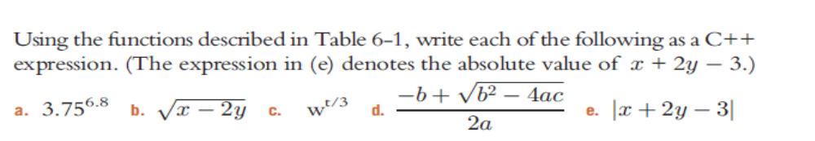
a. pow(3.75, 6.8)
b. sqrt(x – 2 * y)
c. pow(w, t / 3)
d. (-b + sqrt(b * b – 4 * a * c)) / (2 * a)
e. fabs(x + 2 * y - 3)
Q3.
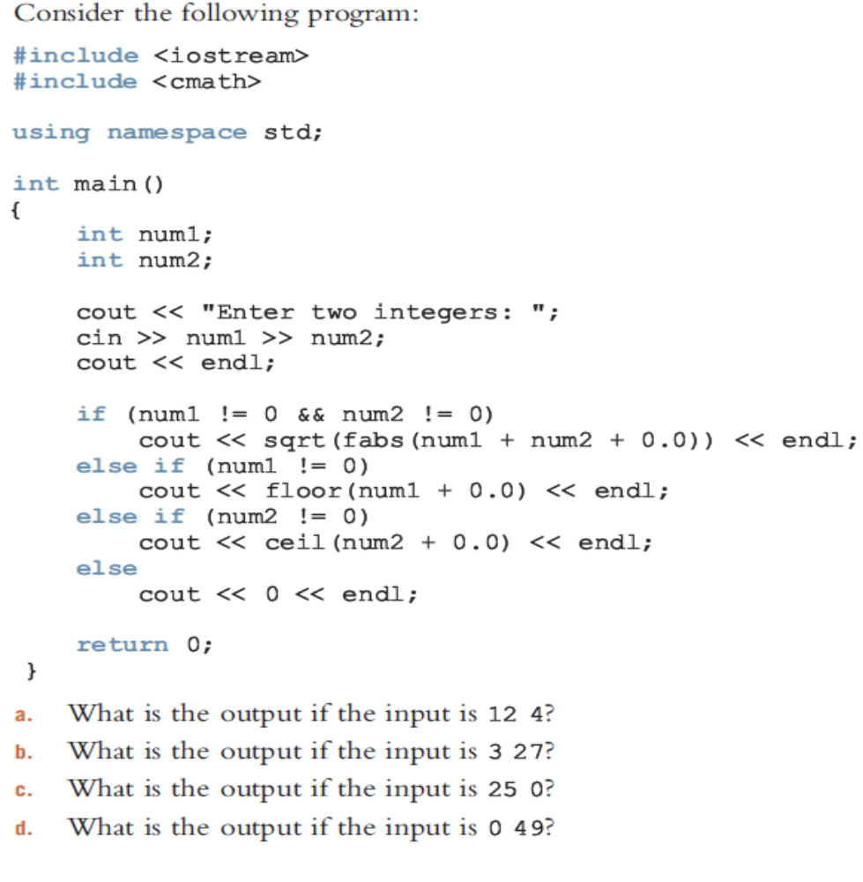
a. 3
b. 5.47723
c. 25
d. 49

Q4.
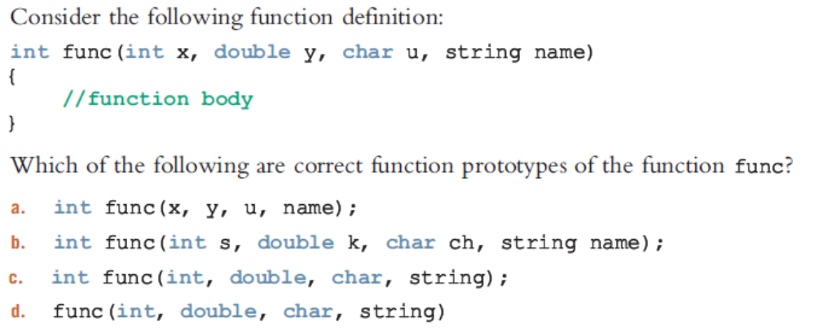
b
d

Q5.
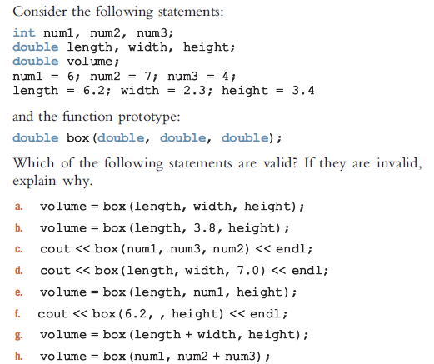
a, b, c, d, e are valid. In f, the second argument in the function call is missing. In g and h, the function call requires one more argument.
Q6.
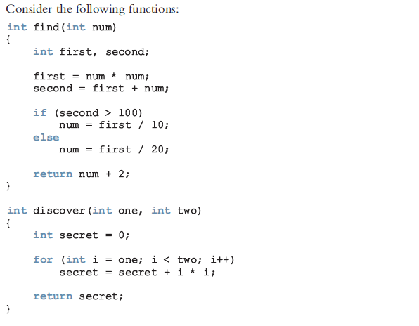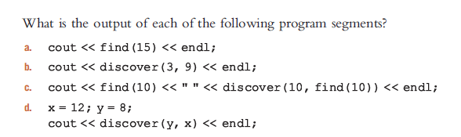

a. 24
b. 199
c. 12 221
d. 366

Q7. Write the definition of a function that takes as input the three numbers.
The function returns true if the first number to the power of the second number equals the third number; otherwise, it returns false. (Assume that the three numbers are of type double.)

bool funcEx14(double x, double y, double z)
{
if (pow(x, y) == z)
return true;
else
return false;
}

Q8. Write the definition of a function that takes as input three decimal numbers and returns the first number multiplied by the second number to the power of the third number.

double funcEx17(double x, double y, double z)
{
return x * pow(y, z);
}

